**EARLY PREDICTION FOR CHRONIC KIDNEY DISEASE:**

**A PROGRESSIVE APPROACH TO HEALTH MANAGEMENT**

**INTRODUCTION**

**OVERVIEW:**

CKD is the significant contributor to morbidity and mortality from non-communicable disease that can affected by 10-15% of the global population.

Early and accurate detection of the stages of CKD is believed to be vital to minimize impacts of patient’s health complication such as Hypertension, anemia(low blood count) mineral bone disorder, poor nutritional health, acid base abnormalities and neurological complications.

The prediction model used include Decision Tree(DT), Support vector machine(SVM), Navie Bayes(NB).A report from 1990 to 2013 indicated that the global yearly life loss caused by CKD increased by 90% & it is the 13th leading cause of death in the world[1].

According to the report of the world kidney day of 2019,atleast 2.4 million people die every year.

According to WHO report of 2017,the number of deaths in Ethiopia due to kidney disease was 4,875.The age-adjusted death rate is 8.46 per 100,000 of the population & the death rate increased to 12.70 per 100,000 that has ranked the country 109 in 2018.

Predictive analysis using ML techniques can be helpful through an early detection of CKD for efficient & timely interventions. In this study,(SVM), (DT),(NB) have been used to detect CKD.

**PURPOSE**

In 2006, CDC established the Chronic Kidney Disease (CKD) Initiative to **provide public health strategies for promoting kidney health**. These strategies seek to: Prevent and control risk factors for CKD. Raise awareness of CKD and its complications.

Academic achievement in children with chronic kidney disease: a report from the CKiD cohort

WIAT-II-A data were available for 319 children in the CKiD cohort. Low total academic achievement was present in 34% percent of the sample. There was no significant effect of CKD-related medical variables on academic achievement. Mathematics had the lowest distribution of achievement scores. In univariate models, low achievement was significantly related to days of missed school (p = 0.006) and presence of individualized education plan (p < 0.0001).

Low academic achievement was seen in over one-third of children with CKD, with the most difficulty observed in the domain of mathematics. Providers and educators should monitor for academic difficulties in this population in order to facilitate early educational assistance and promote positive educational outcomes.

**PROBLEM DEFINITION & DESIGN THINKING**

**Empathy Map**

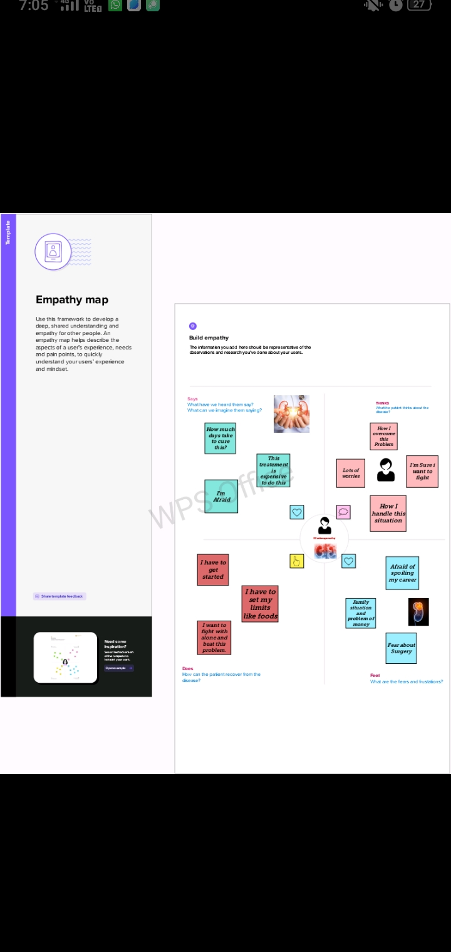

**Ideation & Brainstorming Map**

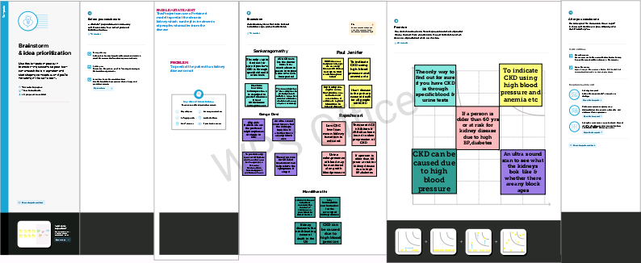

**RESULT**

**Importing the Libraries**

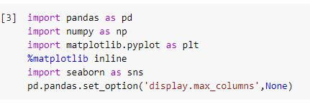

**Read the Dataset**

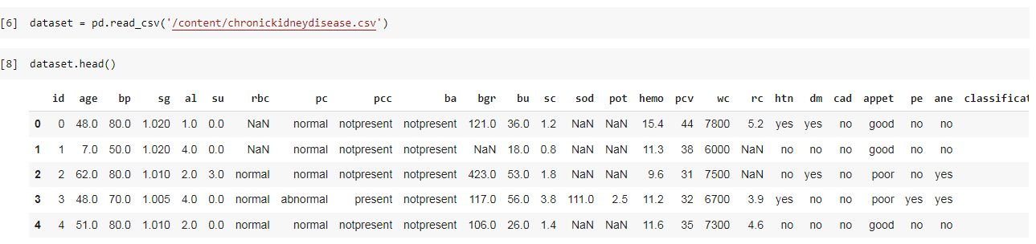

**DATA PREPARATION**

Rename the columns

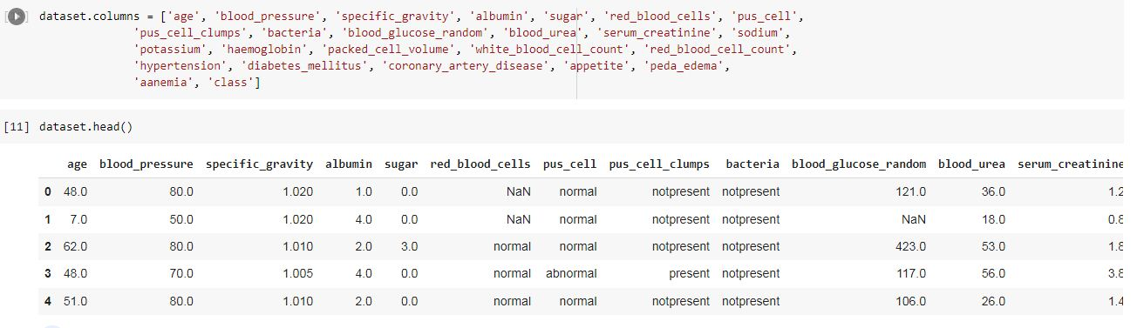

Handling missing values

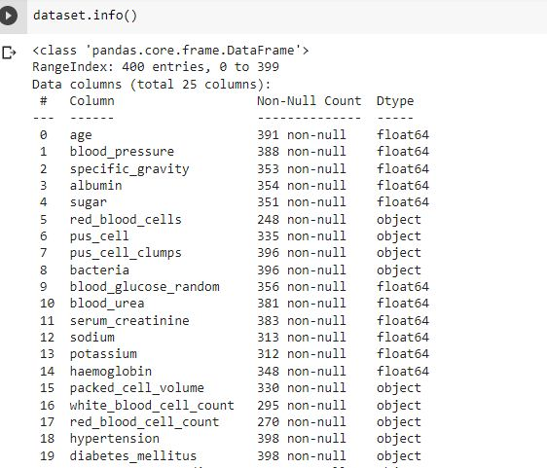

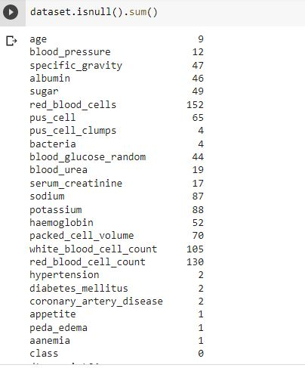

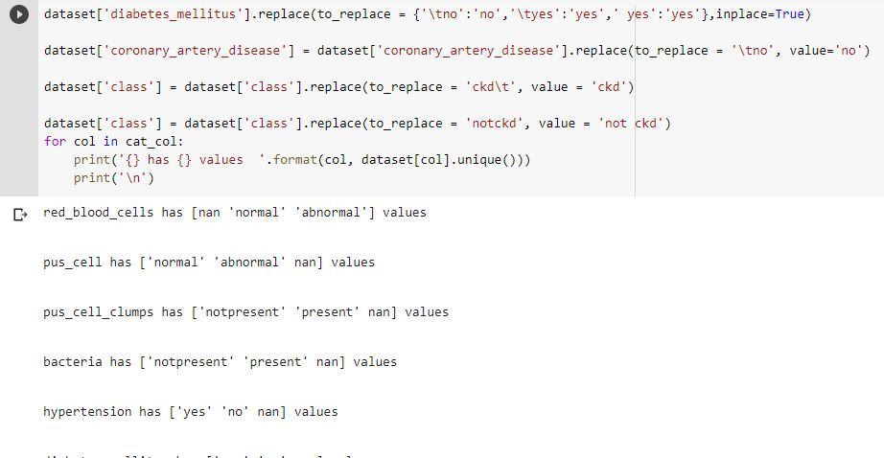

Handling Categorical & Numerical Columns

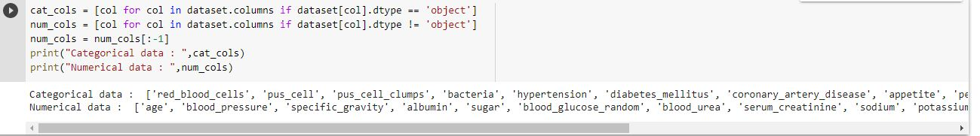

**EXPLORATORY DATA ANALYSIS**

Descriptive statistical Analysis

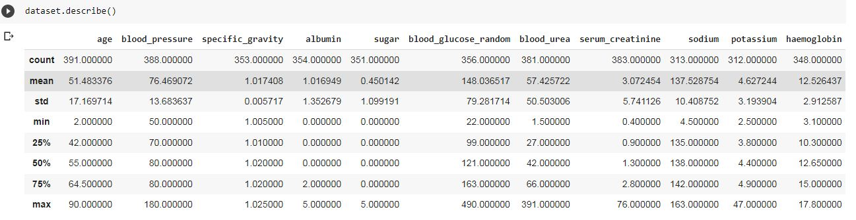

Univariate Analysis

**C:\Users\admin\Contacts\Desktop\univariate analysis.JPG**

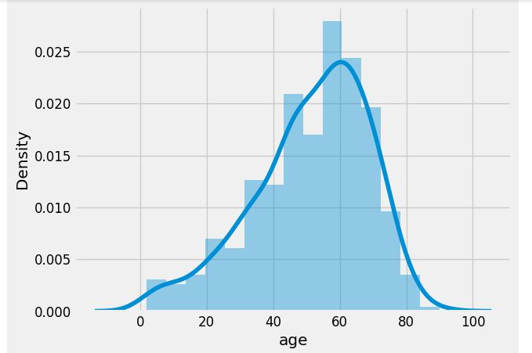

Bivariate Analysis

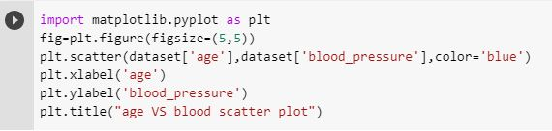

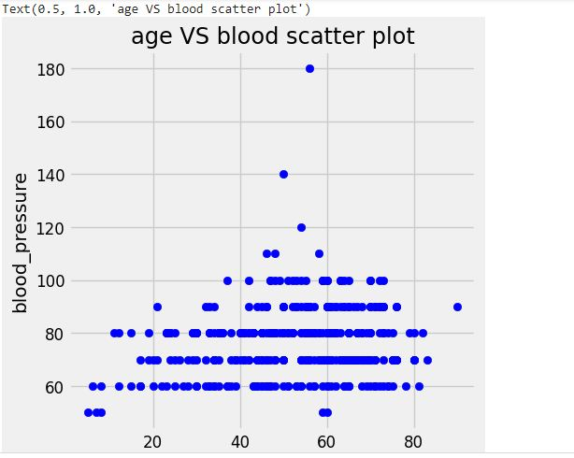

**MODEL BUILDING** Training the model in multiple algorithms

Navie Bayes Model

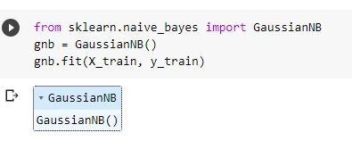

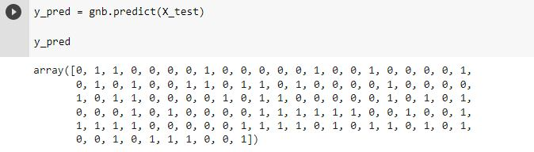

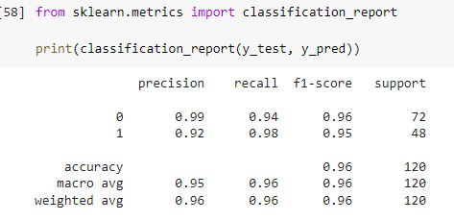

K-Nearest Neighbor Model

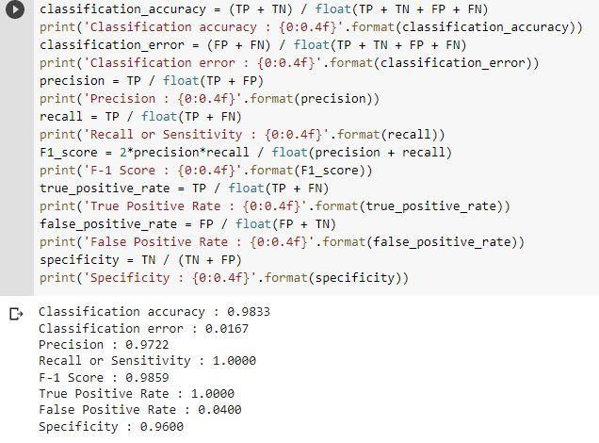

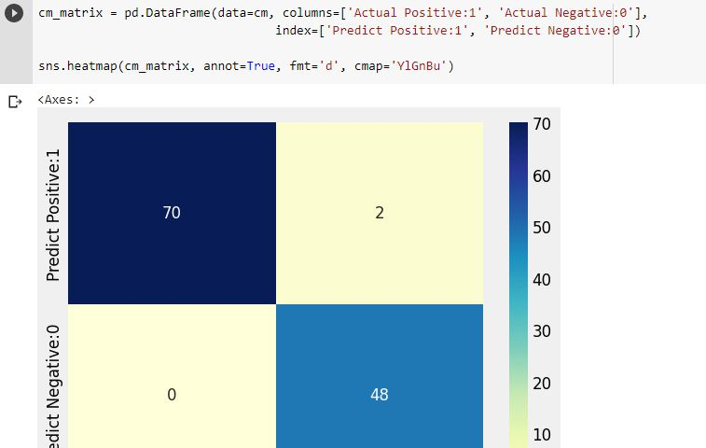

Decision Tree Model

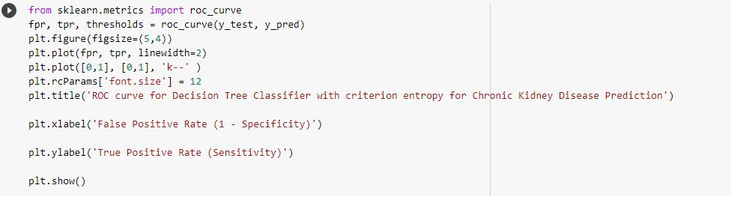

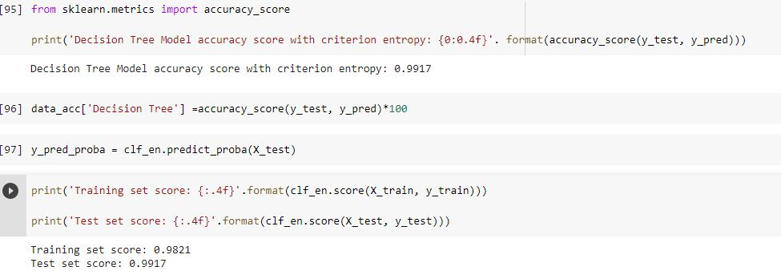

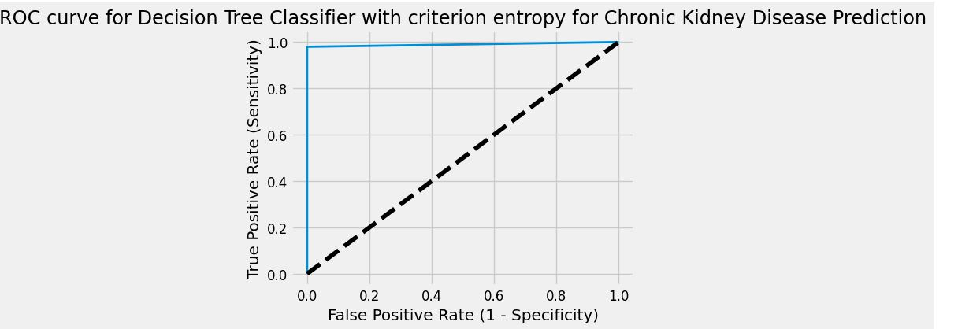

Support Vector Machine Model

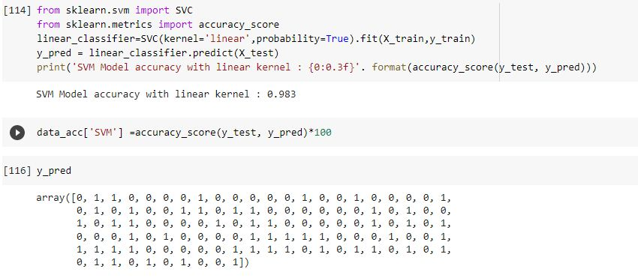

**ADVANTAGES & DISADVANTAGES OF PROPOSED SOLUTION**

**ADVANTAGE:**

* Early detection of CKD allows proper management that could slow down CKD progression, prevent cardiovascular and other comorbidities and enable timely initiation of dialysis. Screening for CKD could be best managed by partnership between primary care physicians and nephrologists.
* Kidney function tests **check how well your kidneys are working**. Healthy kidneys assist with removing waste from your body.
* Conditions such as diabetes or high blood pressure can affect your kidney function. You may also need a kidney function test to diagnose or rule out an infection.

**DISADVANTAGE**:

## Heart Disease and Stroke

* Having CKD increases the chances of having heart disease and stroke.
* Managing high blood pressure, blood sugar, and cholesterol levels—all factors that increase the risk for heart disease and stroke—is very important for people with CKD.

## Early Death

Adults with CKD are at a higher risk of dying earlier than adults of similar age without CKD.

## Health Problems Due to Low Kidney Function

* A weakened immune system, which make it easier to develop infections.
* Loss of appetite or nausea.
* Decreased sexual response.

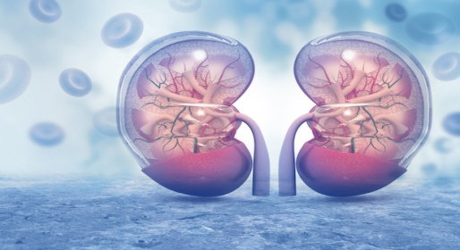

APPLICATIONS:

In kNN, the decision is made by calculating the Euclidian distances between a query and each example in the data, hoosing the value of the example (k) that is closest to the query, and either choosing the most common label for classification or the average of the labels for regression.The value of k is automatically chosen to increase the accuracy of the kNN algorithm.

Support vector machine (SVM) is a promising classical learning method for classification and regression problems and also solves various linear, non-linear, and practical difficulties.

**MEDSCAN** is an android based application in which Machine Learning and Deep Learning Models are integrated. MEDSCAN is an advanced application that predict the disease on the basis of the XRAY and MRI Scan images. This application uses the advanced models for the prediction of disease.

**CONCLUSION:**

**Severe forms of kidney disease which requires dialysis are curable in some instances**. Even if it is not curable, the patient can still lead a meaningful life while on dialysis. Kidney is the only vital organ which can be replaced long term by a machine with reasonable success.

**FUTURE SCOPE:**

Novel therapeutic alternatives for ESRD include **wearable artificial kidneys, xenotransplantation, stem cell–based therapy, and bioengineered and bio-artificial kidneys**. Of note, one of the main objectives of these novel therapeutic approaches should be to maintain patients at home and to avoid dialysis centers

**APPENDIX**

Source code:

HTML Files:

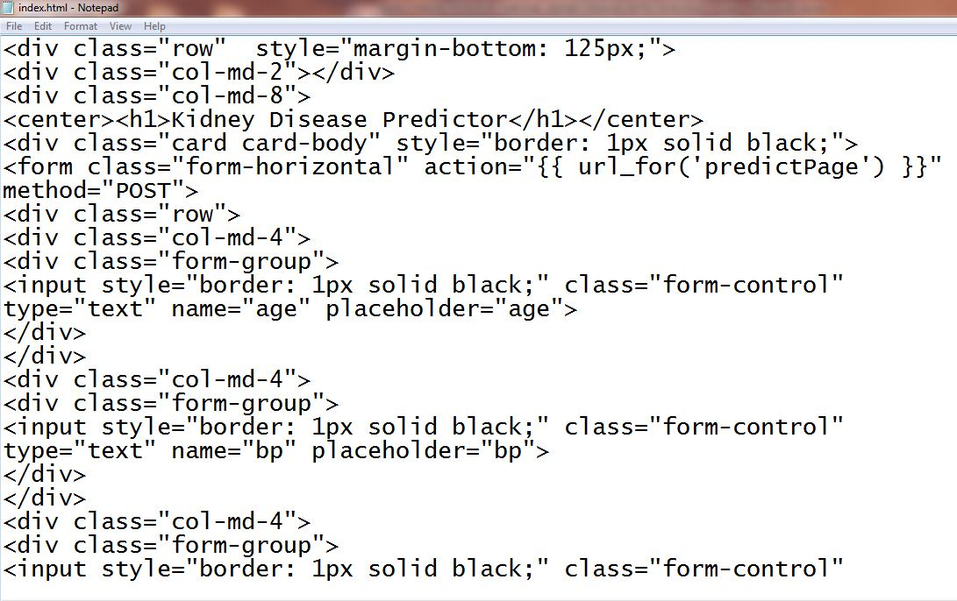

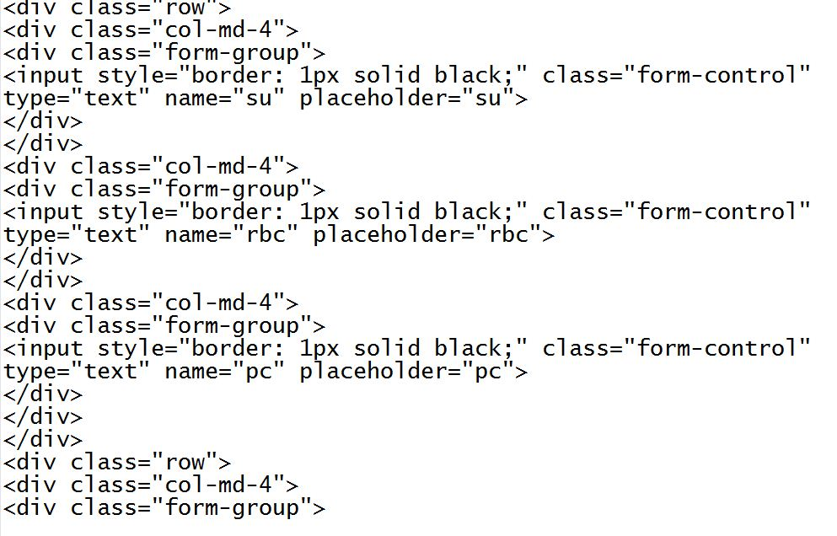

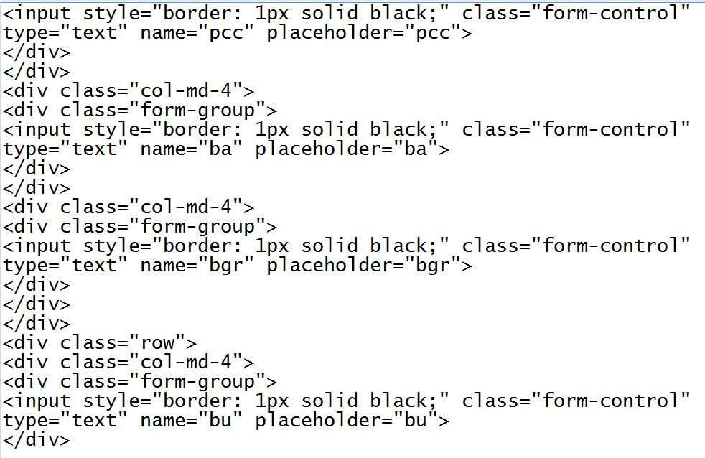

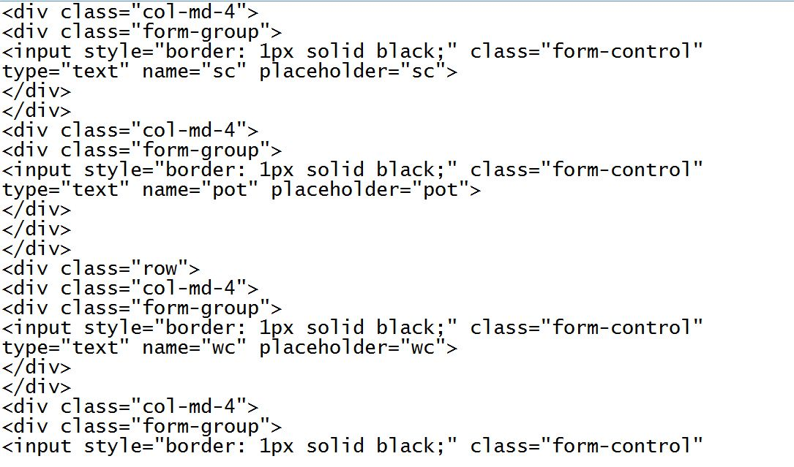

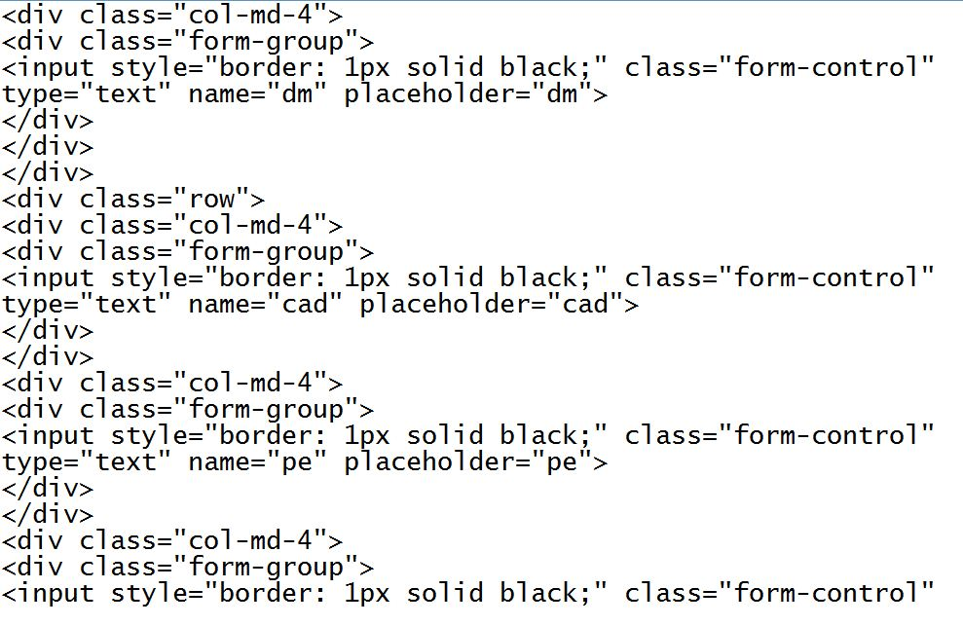

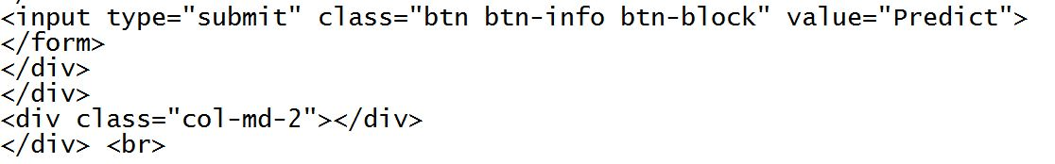

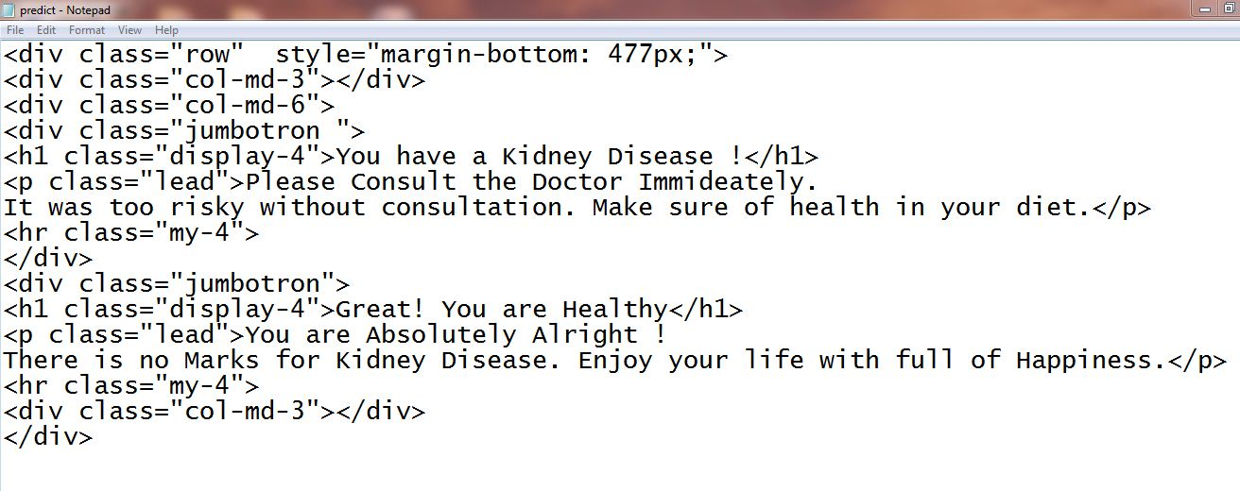

FLASK Files:

